Homes in Sedgemoor - Scrutiny

Resident Engagement in Building Safety

September 2024

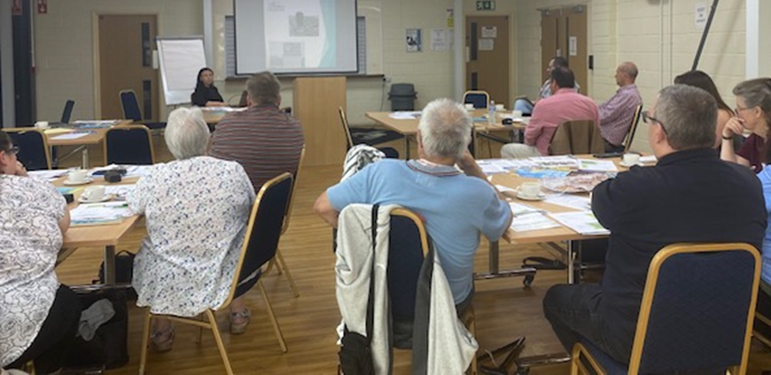

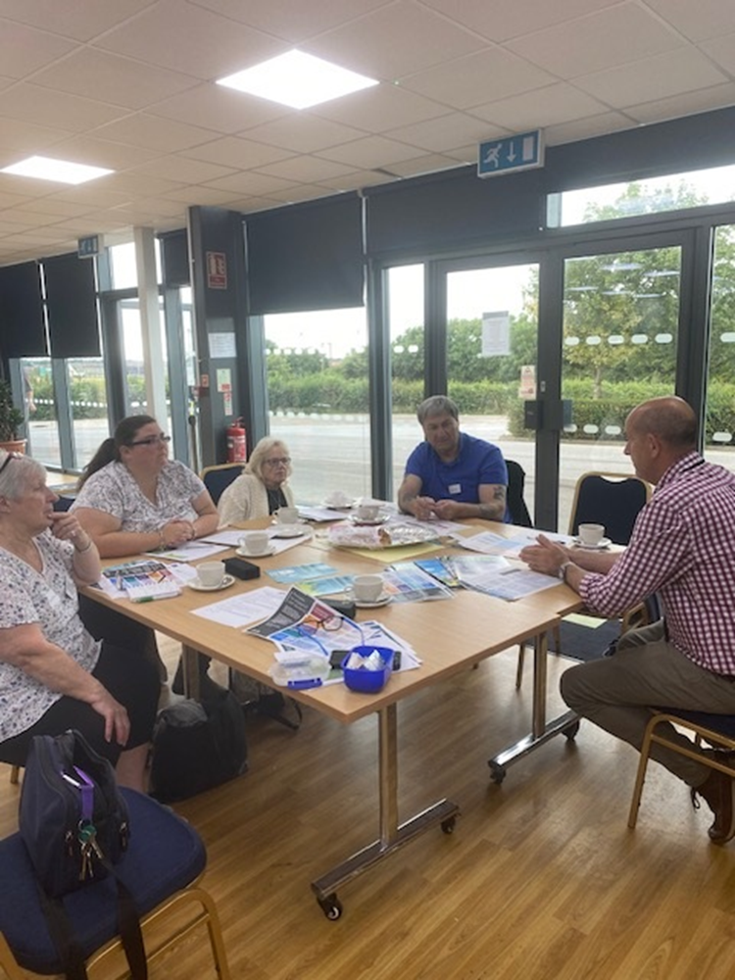

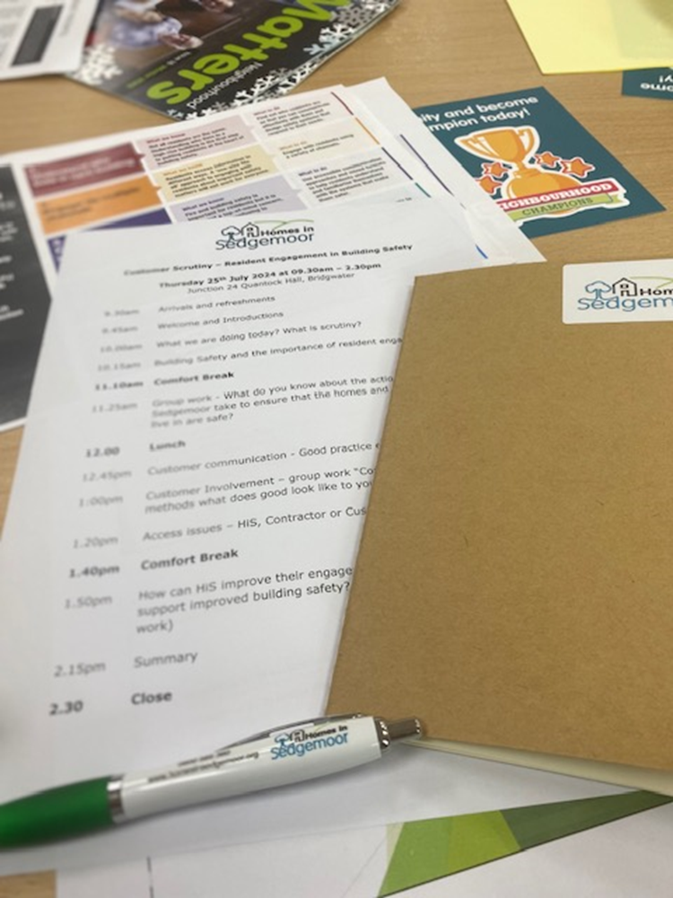



Background

On Thursday 25th July, eleven Homes in Sedgemoor (HiS) customers met in person at Junction 24 to review how we engage with our residents with regards to building safety.

Following new regulations from the Building Safety Act 2022, all buildings over 18 metres or 7 storeys high needed to have a Building Safety case in place by September 2023. HiS only have one building that falls into this category, Westfield House in Bridgwater.
Whilst all residents of Westfield House, were invited to attend, unfortunately those who had initially accepted were then not able to on the day, but we will be carrying out future consultation events specific to this block.

We have a small action plan that we will be working on, and we anticipate an inspection of Westfield House from the Building Safety Regulator between now and 2029.

For all properties managed by HiS, we produce a comprehensive monthly compliance report outlining our performance with regards to the safety of our homes, including such areas as fire safety, gas servicing, electrical safety checks and damp and mould.

Overview of the day

The session was led by Lindsey Hoggard, Compliance and Building Safety Manager, with support from Neil Richards and Pete Bailey, Compliance Team Leaders.

The session began with Sharon Collard, Community Enabler providing an overview of scrutiny and the importance of involving customers in designing the delivery of our services.

Lindsey Hoggard then provided a presentation around Building Safety and the importance of resident engagement, especially regarding our management of high-rise dwellings and blocks with communal areas.

This was followed by several group work sessions.

Customers were supported throughout the day by Sharon Collard, Community Enabler and Jade Cox, Focus and Enabling Assistant.

It was a very productive day with excellent engagement, and we would like to thank everyone for their involvement.

Methodology

The scrutiny review was carried out over a full day with 11 HiS customers.

- The procurement presentation presented by Lindsey Hoggard included:
  - recent incidents,
  - the Hackitt review,
  - the Building Safety Regulators approach to engaging customers and,
  - principles set by the Health and Safety Executive.

- Group work - What do you know about the actions Homes in Sedgemoor take to ensure that the homes and buildings you live in are safe?

- Customer communication – The group were given good practice examples of communication with customers around building safety. Much of the requirements for customer communication comes from the Building Safety act, so customers were informed of future plans to hold consultation meetings with residents within Westfield House for works

- Customer Involvement – group work “Communication methods what does good look like to you?”- The attendees split into groups to discuss and note down all the things that support good customer involvement practice.

- Access issues – HiS, Contractor or Customer issue? This section involved the group looking at responsibilities of contractors, customers and HiS.

- Final group work section - How can HiS improve their engagement with customers to support improved building safety?

Summary of Findings

- Customers have a good to excellent understanding of the checks required to keep them safe within their homes and the reasons for this. The frequency and requirements for ad hoc checks could be explained in more detail.
- Homes in Sedgemoor have a good variety of communication methods for customers with options for braille / translation into other languages on request. Documents on the website are in an accessible format (?)
- Improving communication with non-English speaking customers is needed.
- Our approach needs to be more tailored to individual customers.
- Initial contact informing customers of checks is generally positive.
- Action should be taken against customers not allowing access to complete safety checks when all options and needs have been taken into consideration.
- Initial notification of planned works has improved.
- Changes to plans are not always well communicated.
- Contractors need to improve communication with customers and ensure they tailor their contact to their needs.
- Website needs to be improved to contain more information.

Recommendations

Recommendation | Comments | Lead | HiS Response
- Better understand the individual needs of customers and how best to communicate with them. | New Vulnerable Persons & Reasonable Adjustments policy now in place | CFM | Customer Insight project  On-going and new corporate project  As from April 2025
- Ensure some of the key documents and letters sent to customers e.g no access letters are translated where customers have indicated that English is a second language. | Need to ensure that we are being inclusive and ensuring access to services is same for all customers | CBSM / CM | Review of key letters  Introducing call cards for all compliance – to be translated into main languages  By March 2025
- To ensure at sign up HiS check the reading language of the customer. |  | HM | Complete
- More promotion to advise customers to let HiS know of a change in circumstances e.g broken leg might require PEEP. | Use of communal notice-boards/Social Media etc | CBSM / HM / CM | Comms plan to be produced  Complete  All notice boards to be updated for Homes in Somerset  By March 2025
- Complete more analysis to have a better understanding of customers not allowing access, e.g what % does not have English as their first language? | Compliance report / OPEN Housing | CBSM | Links to Customer Insight project as above  Complete - new
- Improve the sign-up process, make the process an in person sign up to support customer understanding of everything involved in managing a tenancy to ensure their safety. | Under review and next scrutiny to cover the Voids & Lettings process | HM / PSM | Review underway and will link in with next customer scrutiny event  Pilot for Patch B as from 1st March – new tenants to be met at property by member of patch them  By March 2025
- Review our approach towards customers that do not allow access to carry out checks and complete work within their homes. | Reports to be available from OPEN Housing  Links to our Vulnerable Persons & Reasonable Adjustments policy | SLT | Review SOP for no access process  Complete  Using TM to assist with logging  Reviewed at Patch team meetings to ensure cross-tea approach to support customers  New access policy being drafted  By March 2025
- Work closely with contractors to improve - ensure customers are advised when operatives cannot attend, ensure they knock loud enough and give customers time to get to the door. | Regular meetings are held with key contractors;  Customers First refresher training underway | PSM / CFM | Review meeting agendas to ensure Customers First is embedded  Complete  By March 2025
- Review the communication process regarding informing customers of work from initial contact through to work completion including managing changes. | Need to ensure this happens for all works – have been working on improving the retrofit process | PSM / CFM / CM | Review SOP for planned works  New Retrofit CLO in post  By March 2025
10.Create specific web pages relating compliance and building safety to promote safe practices within the home and highlight key checks that will be carried out. | Web champions being re-instated to ensure all areas of website are up to date | SLT | To be produced in conjunction with SIP  In progress  By March 2025

